<Fisier> ::= <Alfabet>’\n’<Linie>

<Alfabet> ::= <Caracter> ‘ ‘ <Alfabet> |

<Caracter>

<Caracter> ::= ^[a-z 0-9]

<Linie> ::= <Lista_stari> ‘ ‘ <Final_sau_nefinal> ‘\n’ <Linie> |

<Lista_stari> ‘ ‘ <Final_sau_nefinal>

<Lista_stari> ::= <Stare> ‘ ‘ <Lista_stari> |

<Stari> ‘ ‘ <Lista_stari> |

<Stare> |

<Stari>

<Stare> ::= ^[a-z]

<Stari> ::= <Stare> ‘,’ <Stari> |

<Stare>

<Final_sau_nefinal> ::= 0 | 1

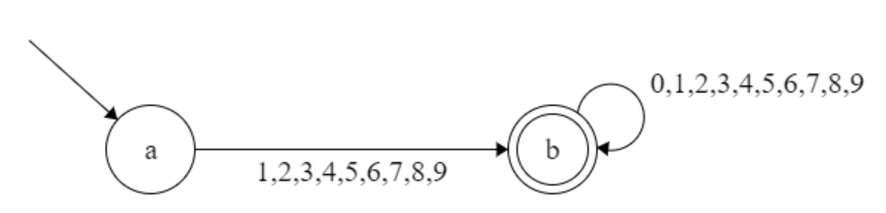

0 1 2 3 4 5 6 7 8 9  
a - b b b b b b b b b 0  
b b b b b b b b b b b 1